*Assignment - Tableau [Major]*

28-07-2023

General requirements

1. Dashboard size is 1250 px wide by 750 px tall.

2. Prefer using containers.

3. The dashboard has maximum 5 containers.

4. The filter pane consists category, sub-category, region, segment

5. Do proper formatting.

6. Total 3 charts which should be placed horizontally one after

other.

7. Dashboard title “Executive sales”.

**Q 1** ⟹ Create the dashboard with following the general requirements In the dashboard following sheets required

1. First sheet should have total discount, proﬁt, quantity and sales (KPI format preferred means only number- no chart)

Ans.

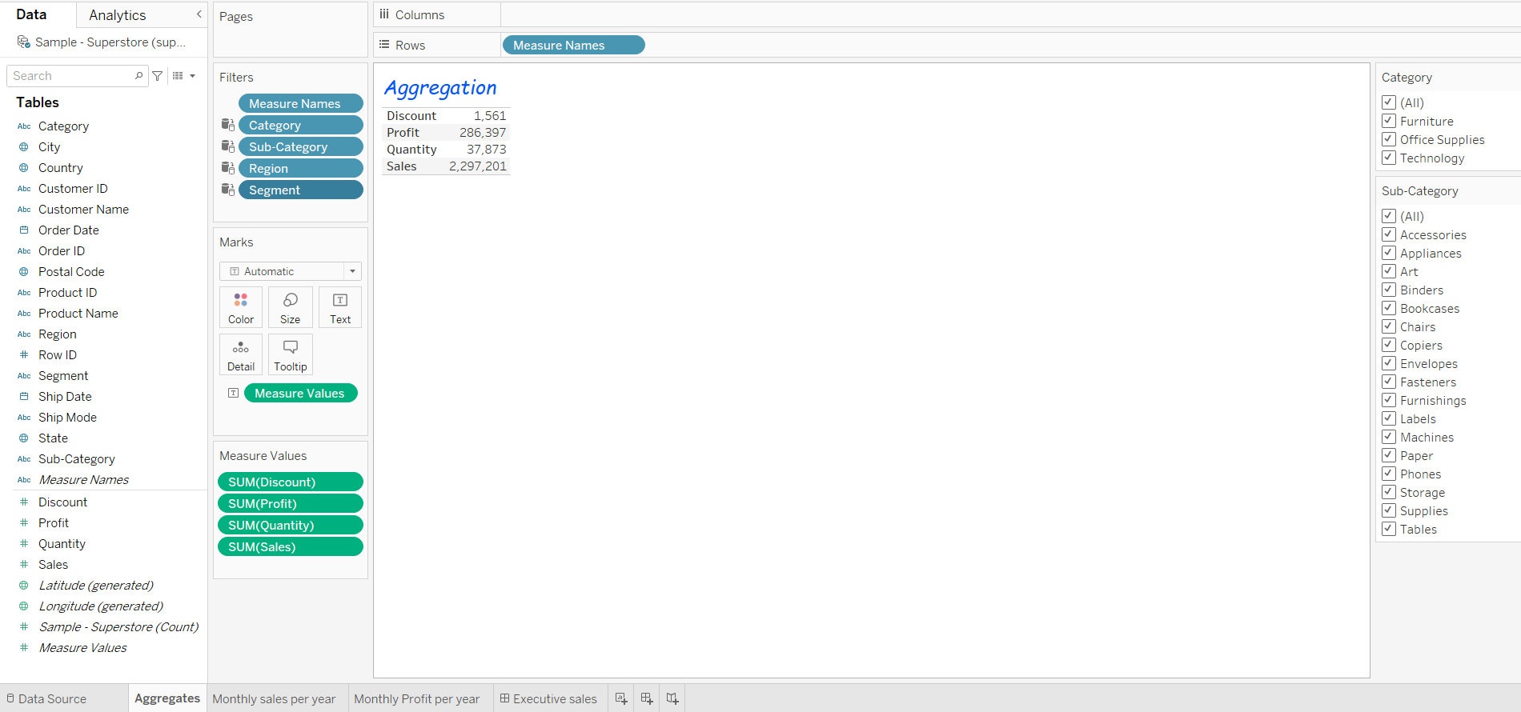

1. Second sheet shows monthly sales per year

Ans.

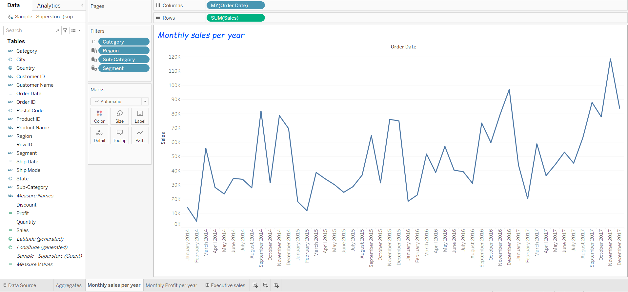

1. Third sheet shows monthly proﬁt per year

Ans.

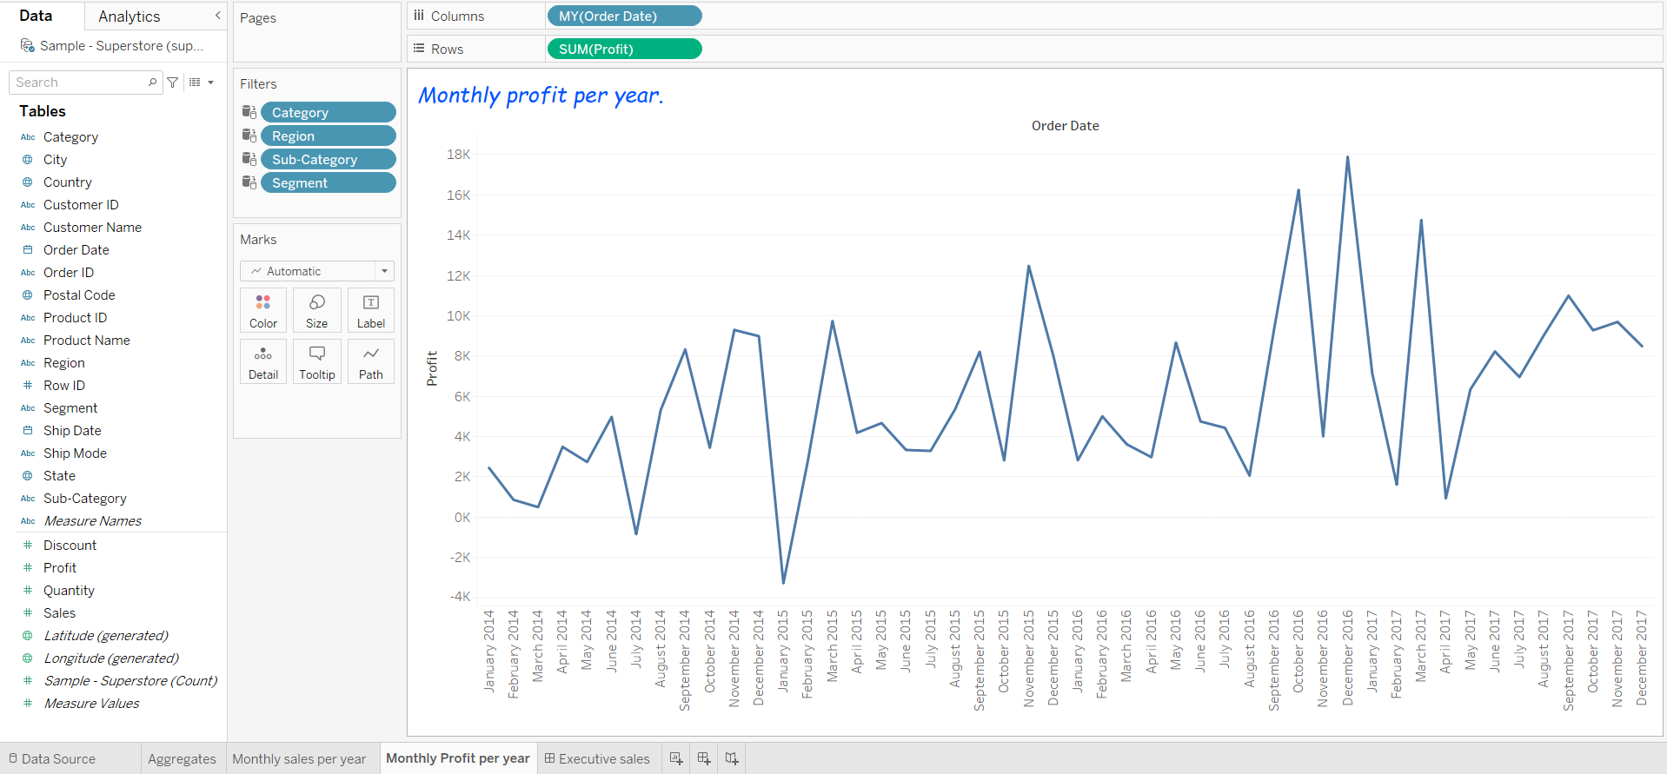

*Dashboard:-*

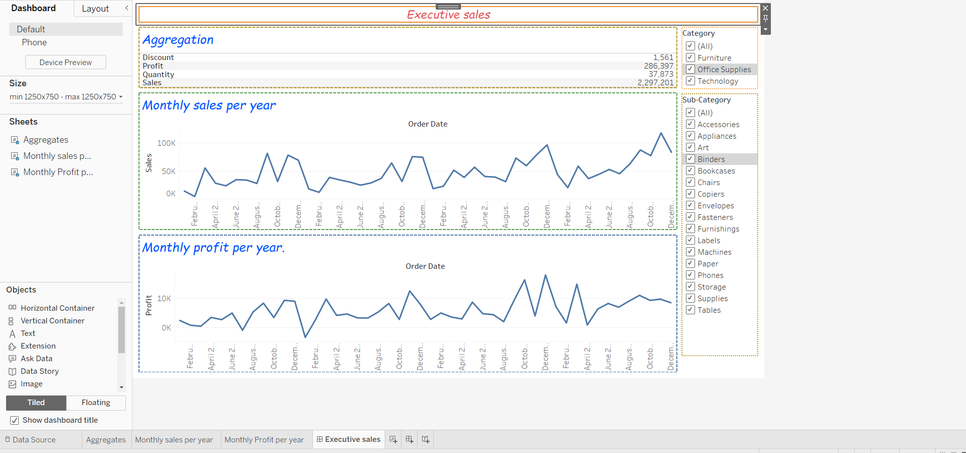

**Q 2** ⟹ Answer the following questions

1. Top 5 cities which bears maximum loss.

Ans.Philadelphia, Houston, San Antonio, Lancaster, Chicago.

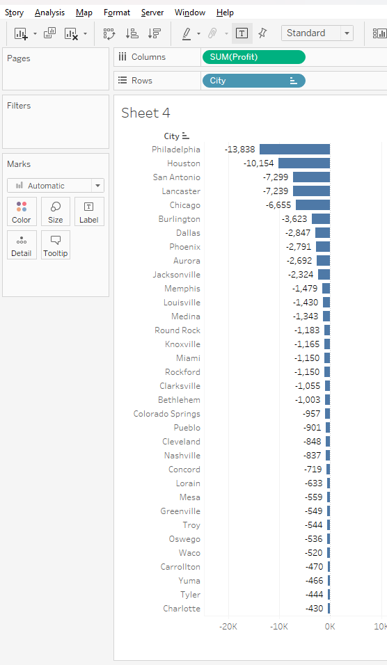

1. Which is the region with highest sales

Ans.West

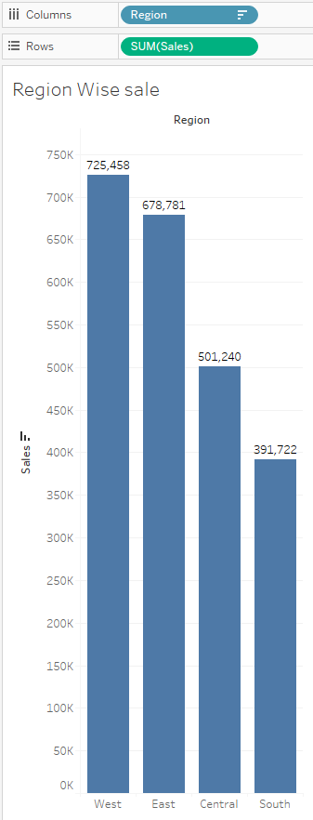

1. Name category in region with highest sales.

Ans.

Technology category has the highest sales in the East region.

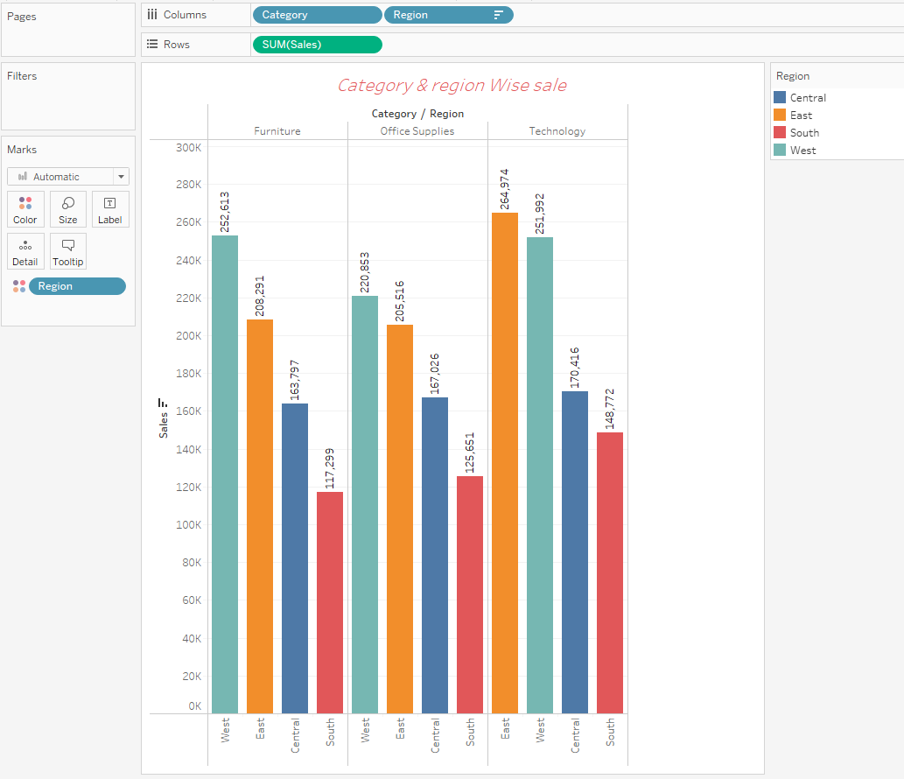

1. Which state has highest quantity of orders

Ans.

California

